Fatigue Risk Management

Resident Assessment Tool (1 of 2)

How Sleepy Are You?

How likely are you to doze off or fall asleep in the following situations? You should rate your chances of dozing off, not just feeling tired. Even if you have not done some of these things recently try to determine how they would have affected you. For each situation, decide whether or not you would have:

**No chance of dozing = 0**

**Slight chance of dozing = 1**

**Moderate chance of dozing = 2**

**High chance of dozing = 3**

Write down the number corresponding to your choice in the right-hand column and total your score below

|  |  |
| --- | --- |
| Situation | Chance of dozing |
| Sitting and reading |  |
| Watching television |  |
| Sitting inactive in a public place (e.g. a theater or a meeting) |  |
| As a passenger in a car for an hour without a break |  |
| Lying down to rest in the afternoon when circumstances permit |  |
| Sitting and talking to someone |  |
| Sitting quietly after a lunch without alcohol |  |
| In a car, while stopped for a few minutes in traffic |  |

ESS Total Score: ________

**Analyze your score:**

**0-7:** It is unlikely that you are abnormally sleepy

**8-9:** You have an average amount of daytime sleepiness

**10-15:** You may be excessively sleepy depending on the situation. You may want to consider seeking medical attention

**16-24:** You are excessively sleepy and should consider seeking medical attention

*Reference: Johns MW. A new method for measuring daytime sleepiness: The Epworth Sleepiness Scale. Sleep 1991; 14(6):540-5*.

Fatigue Risk Management

Resident Assessment Tool (2 of 2)

Fatigue Severity Scale:

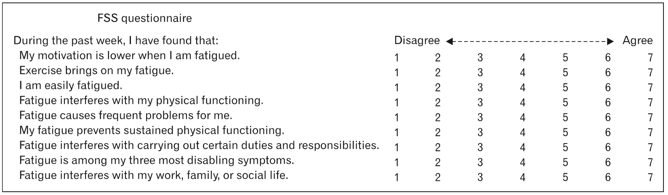

FSS total Score: __________

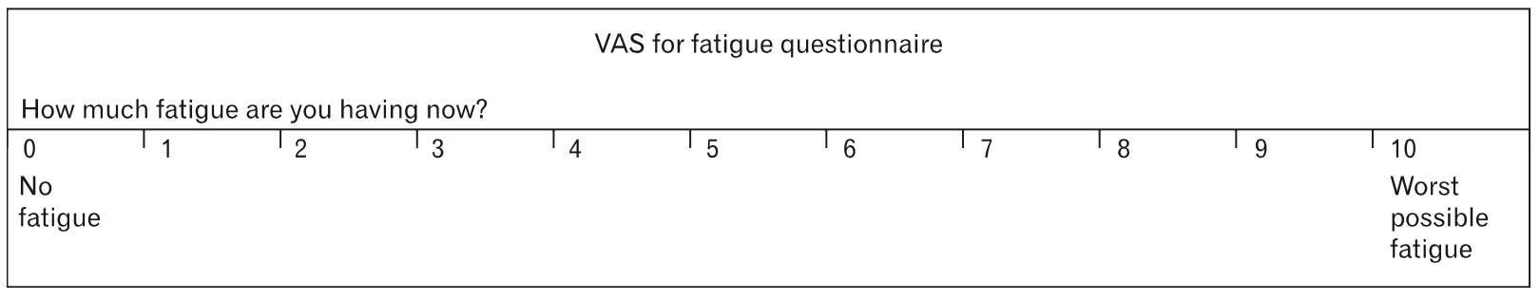

VAS value: ___________

*Reference: Krupp LB, LaRocca NG, Muir-Nash J, Steinberg AD. The fatigue severity scale. Application to patients with multiple sclerosis and systemic lupus erythematosus. Arch Neurol. 1989 Oct;46(10):1121-3*